November 6, 2024

Fort Myers Amateur Radio Club Inc.

PO Box 061183

Fort Myers, Fl. 33906

Dear Mr. Clayton and our Hamm Radio Friends,

We cannot thank you enough for all your help during our Haunted Hike on Friday night. The club members who volunteered to assist us with our show were friendly, helpful, and efficient. The students are asking for them by name to come back each year because of how wonderful they were! We appreciate you all very much and look forward to working with you in the future.

Thank you again for going out of your way to support the performing arts in our public schools.

Theatrically yours,

Jerri-Lynne M. Clayton

Theater Director and Educator

Paul Laurence Dunbar Middle School

239-334-1357 Ext: 2201

[JerriLynneMC@LeeSchools.net](mailto:JerriLynneMC@LeeSchools.net)

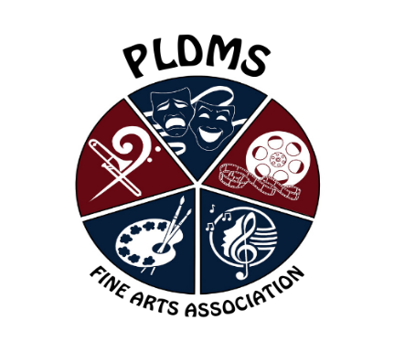

***Trent Eckhardt - Principal***

***www.dun.leeschools.net***

4750 Winkler Ave Ext  
Fort Myers, FL 33966  
239/334-1357 phone  
239/334-7633 fax

Paul Laurence Dunbar Middle School

*Home of the Soaring Eagles*

